**WITH NOISE AND WITHOUT FILTER FUZZY**

**Image set:**

|  |
| --- |
| **Image 1:-0.1 % Noise** |

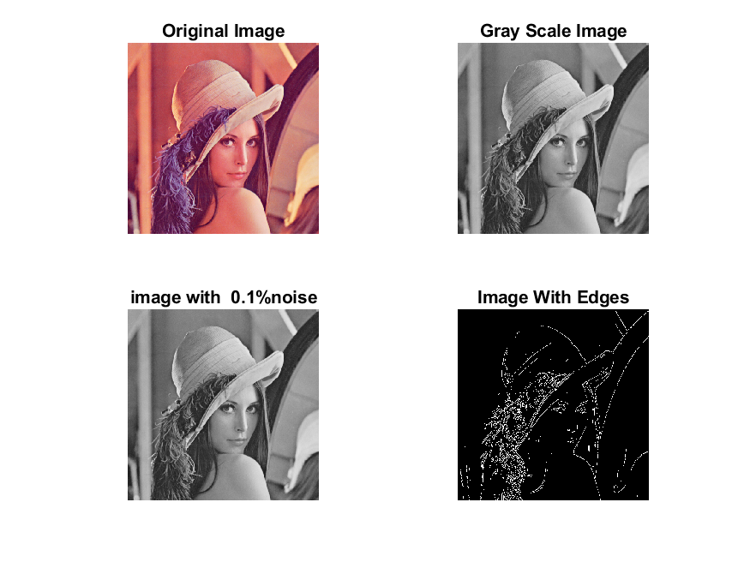

**Image 2:-10 % Noise**

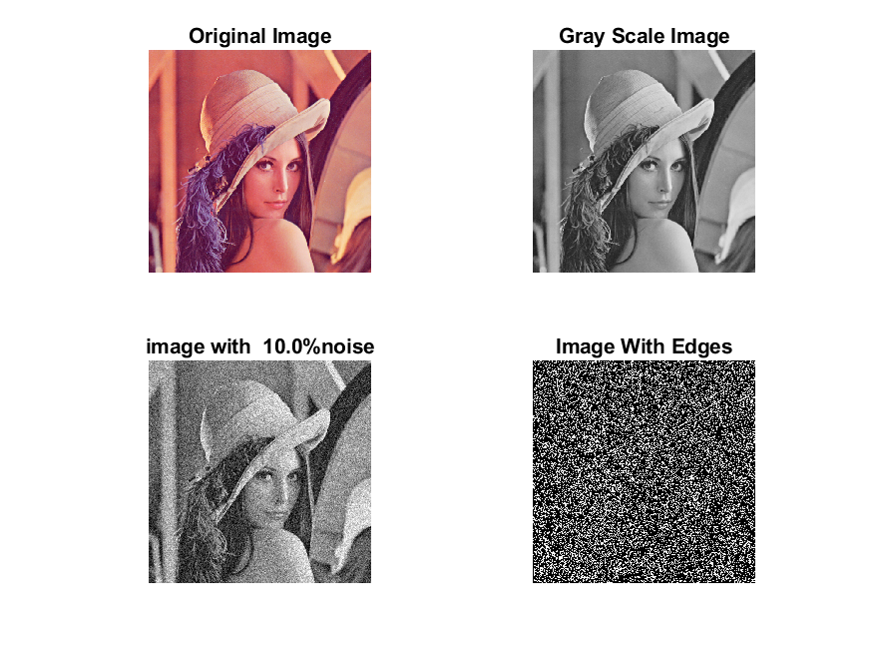

**Image 3:-20 % Noise**

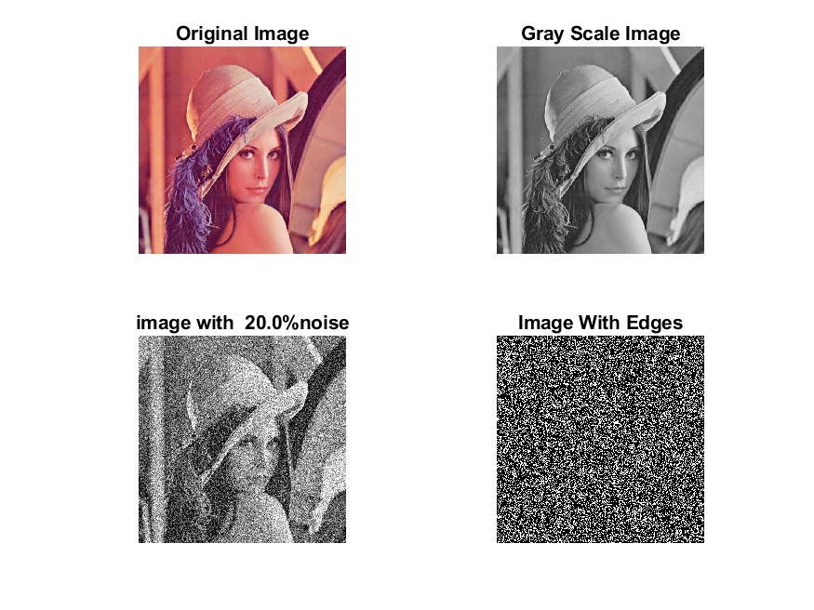

**Image 4:-30 % Noise**

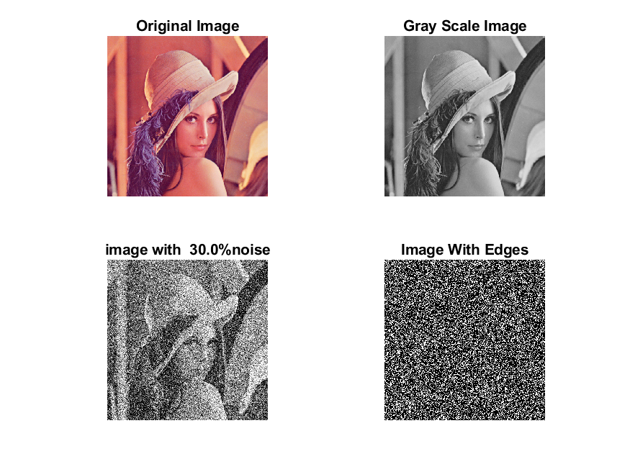

|  |
| --- |
| **Image 5:-40 % Noise** |

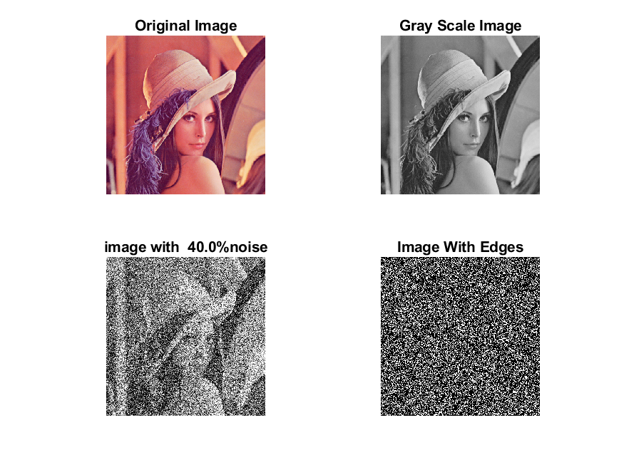

**Image 6:-50 % Noise**

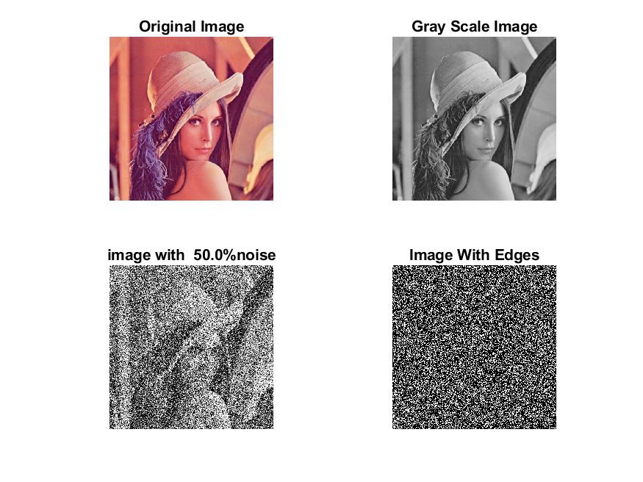

**Image 7:-60 % Noise**

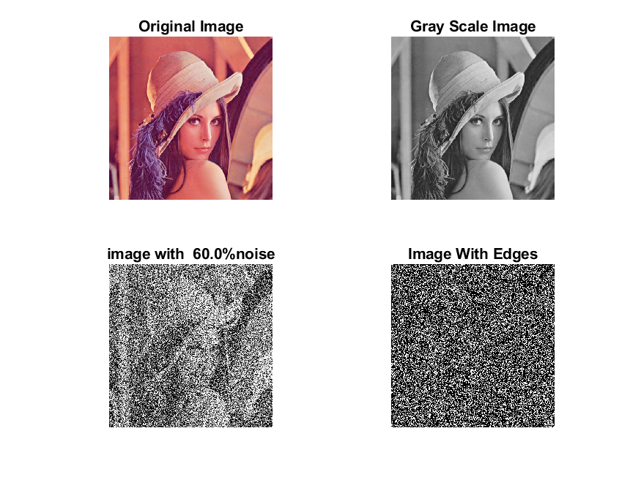

**Image 8:-70 % Noise**

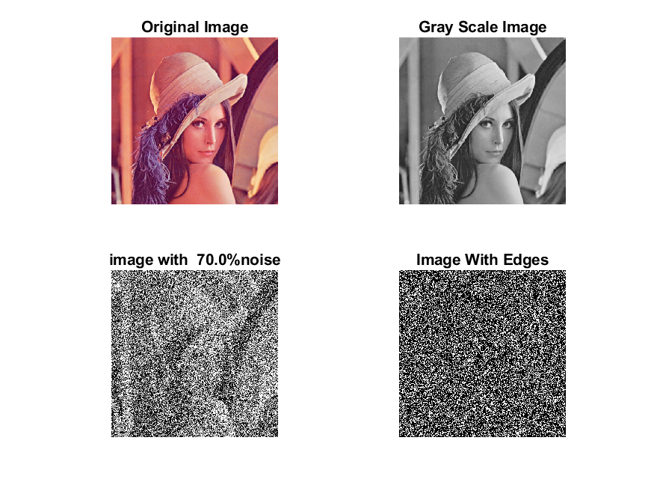

**Image 9:-80 % Noise**

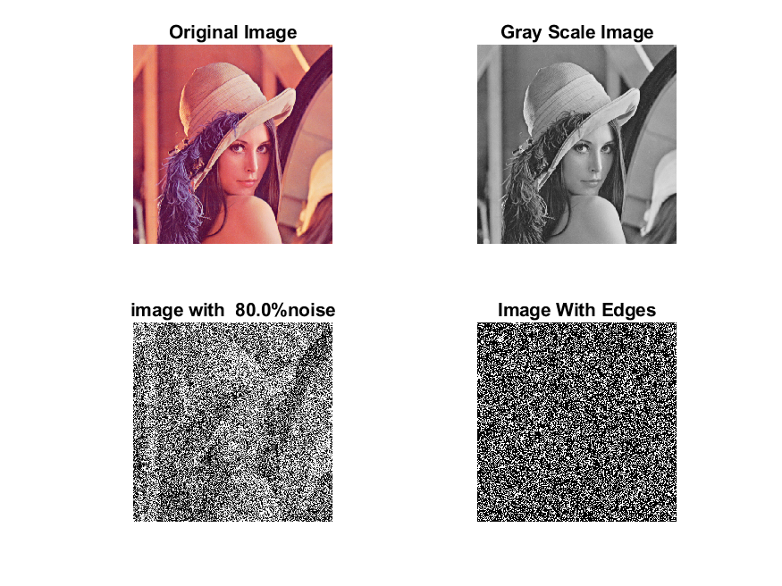

**DATA FILES**

**Image 1:-Noise0.1**

Original image ideal values:

IM1 image entropy:2.587231e-01

IM1 image mean:0.043636

Ground truth image entropy:0.633825

Ground truth image mean:0.159798

entropy between imt and im1 :0.597157

MSE between imt and im1 :0.173817

Average Difference between imt and im1 :0.116161

Maximum Difference between imt and im1 :1.000000

True Positive values:3882.000000

False Positive values: 7557.000000

True Negative values:212697.000000

False Negative values:38008.000000

Accuracy value: 0.826183

F Measure values:0.145587

Peak Signal-to Noise Ration value: 7.599085

Signal-to Noise Ration value: -5.637223

percentage of pixels that were correctly detected (Pco): 0.092671

The percentage of pixels that were not detected (Pnd):0.907329

the percentage of false alarm: (Pfa):0.180401

Euclidean Distance Value :8.368063

**Image 2:-Noise10**

Original image ideal values:

IM1 image entropy:8.787809e-01

IM1 image mean:0.297958

Ground truth image entropy:0.633825

Ground truth image mean:0.159798

entropy between imt and im1 :0.503108

MSE between imt and im1 :0.360283

Average Difference between imt and im1 :-0.138161

Maximum Difference between imt and im1 :1.000000

True Positive values:12776.000000

False Positive values: 65332.000000

True Negative values:154922.000000

False Negative values:29114.000000

Accuracy value: 0.639717

F Measure values:0.212937

Peak Signal-to Noise Ration value: 4.433564

Signal-to Noise Ration value: 2.705852

percentage of pixels that were correctly detected (Pco): 0.163568

The percentage of pixels that were not detected (Pnd):0.372740

the percentage of false alarm: (Pfa):0.836432

Euclidean Distance Value :15.407999

**Image 3:-Noise20**

Original image ideal values:

IM1 image entropy:9.142956e-01

IM1 image mean:0.329384

Ground truth image entropy:0.633825

Ground truth image mean:0.159798

entropy between imt and im1 :0.490316

MSE between imt and im1 :0.383270

Average Difference between imt and im1 :-0.169586

Maximum Difference between imt and im1 :1.000000

True Positive values:13882.000000

False Positive values: 72464.000000

True Negative values:147790.000000

False Negative values:28008.000000

Accuracy value: 0.616730

F Measure values:0.216507

Peak Signal-to Noise Ration value: 4.164949

Signal-to Noise Ration value: 3.141319

percentage of pixels that were correctly detected (Pco): 0.160772

The percentage of pixels that were not detected (Pnd):0.324369

the percentage of false alarm: (Pfa):0.839228

Euclidean Distance Value :15.128346

**Image 4:-Noise30**

Original image ideal values:

IM1 image entropy:9.175489e-01

IM1 image mean:0.332588

Ground truth image entropy:0.633825

Ground truth image mean:0.159798

entropy between imt and im1 :0.490013

MSE between imt and im1 :0.386276

Average Difference between imt and im1 :-0.172791

Maximum Difference between imt and im1 :1.000000

True Positive values:13908.000000

False Positive values: 73278.000000

True Negative values:146976.000000

False Negative values:27982.000000

Accuracy value: 0.613724

F Measure values:0.215501

Peak Signal-to Noise Ration value: 4.131020

Signal-to Noise Ration value: 3.183364

percentage of pixels that were correctly detected (Pco): 0.159521

The percentage of pixels that were not detected (Pnd):0.320946

the percentage of false alarm: (Pfa):0.840479

Euclidean Distance Value :15.003745

**Image 5:-Noise40**

Original image ideal values:

IM1 image entropy:9.194082e-01

IM1 image mean:0.334450

Ground truth image entropy:0.633825

Ground truth image mean:0.159798

entropy between imt and im1 :0.487811

MSE between imt and im1 :0.386703

Average Difference between imt and im1 :-0.174652

Maximum Difference between imt and im1 :1.000000

True Positive values:14096.000000

False Positive values: 73578.000000

True Negative values:146676.000000

False Negative values:27794.000000

Accuracy value: 0.613297

F Measure values:0.217591

Peak Signal-to Noise Ration value: 4.126219

Signal-to Noise Ration value: 3.207605

percentage of pixels that were correctly detected (Pco): 0.160777

The percentage of pixels that were not detected (Pnd):0.317015

the percentage of false alarm: (Pfa):0.839223

Euclidean Distance Value :15.128737

**Image 6:-Noise50**

Original image ideal values:

IM1 image entropy:9.221179e-01

IM1 image mean:0.337204

Ground truth image entropy:0.633825

Ground truth image mean:0.159798

entropy between imt and im1 :0.487752

MSE between imt and im1 :0.389420

Average Difference between imt and im1 :-0.177406

Maximum Difference between imt and im1 :1.000000

True Positive values:14101.000000

False Positive values: 74295.000000

True Negative values:145959.000000

False Negative values:27789.000000

Accuracy value: 0.610580

F Measure values:0.216462

Peak Signal-to Noise Ration value: 4.095822

Signal-to Noise Ration value: 3.243223

percentage of pixels that were correctly detected (Pco): 0.159521

The percentage of pixels that were not detected (Pnd):0.314369

the percentage of false alarm: (Pfa):0.840479

Euclidean Distance Value :15.003569

**Image 7:-Noise60**

Original image ideal values:

IM1 image entropy:9.259061e-01

IM1 image mean:0.341141

Ground truth image entropy:0.633825

Ground truth image mean:0.159798

entropy between imt and im1 :0.486495

MSE between imt and im1 :0.392540

Average Difference between imt and im1 :-0.181343

Maximum Difference between imt and im1 :1.000000

True Positive values:14208.000000

False Positive values: 75220.000000

True Negative values:145034.000000

False Negative values:27682.000000

Accuracy value: 0.607460

F Measure values:0.216391

Peak Signal-to Noise Ration value: 4.061161

Signal-to Noise Ration value: 3.293632

percentage of pixels that were correctly detected (Pco): 0.158876

The percentage of pixels that were not detected (Pnd):0.309545

the percentage of false alarm: (Pfa):0.841124

Euclidean Distance Value :14.939308

**Image 8:-Noise70**

Original image ideal values:

IM1 image entropy:9.278165e-01

IM1 image mean:0.343166

Ground truth image entropy:0.633825

Ground truth image mean:0.159798

entropy between imt and im1 :0.485601

MSE between imt and im1 :0.393986

Average Difference between imt and im1 :-0.183369

Maximum Difference between imt and im1 :1.000000

True Positive values:14284.000000

False Positive values: 75675.000000

True Negative values:144579.000000

False Negative values:27606.000000

Accuracy value: 0.606014

F Measure values:0.216672

Peak Signal-to Noise Ration value: 4.045195

Signal-to Noise Ration value: 3.319343

percentage of pixels that were correctly detected (Pco): 0.158783

The percentage of pixels that were not detected (Pnd):0.306873

the percentage of false alarm: (Pfa):0.841217

Euclidean Distance Value :14.929992

**Image 9:-Noise80**

Original image ideal values:

IM1 image entropy:9.308339e-01

IM1 image mean:0.346424

Ground truth image entropy:0.633825

Ground truth image mean:0.159798

entropy between imt and im1 :0.483572

MSE between imt and im1 :0.395931

Average Difference between imt and im1 :-0.186626

Maximum Difference between imt and im1 :1.000000

True Positive values:14456.000000

False Positive values: 76357.000000

True Negative values:143897.000000

False Negative values:27434.000000

Accuracy value: 0.604069

F Measure values:0.217870

Peak Signal-to Noise Ration value: 4.023802

Signal-to Noise Ration value: 3.360377

percentage of pixels that were correctly detected (Pco): 0.159184

The percentage of pixels that were not detected (Pnd):0.302093

the percentage of false alarm: (Pfa):0.840816

Euclidean Distance Value :14.969786